**Assignment Part-3: Playing with Files**

**1. Create a file like nano file1.txt**

**o Edit some data and then save the file**

**Answer:**

Created a file1.txt using nano and added the message “Hello World” and saved the file.

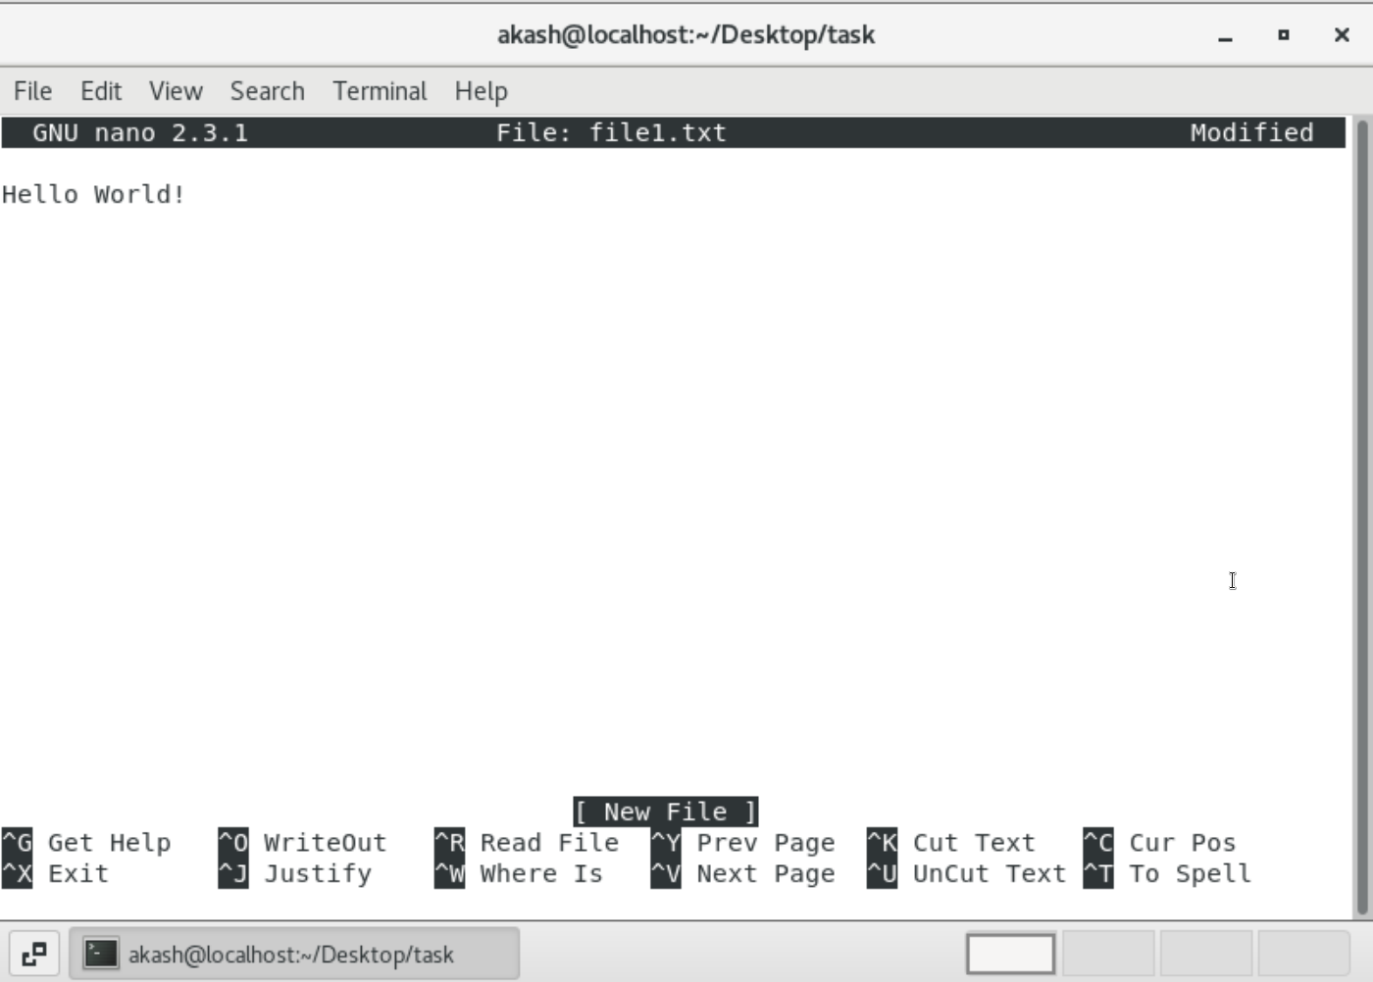

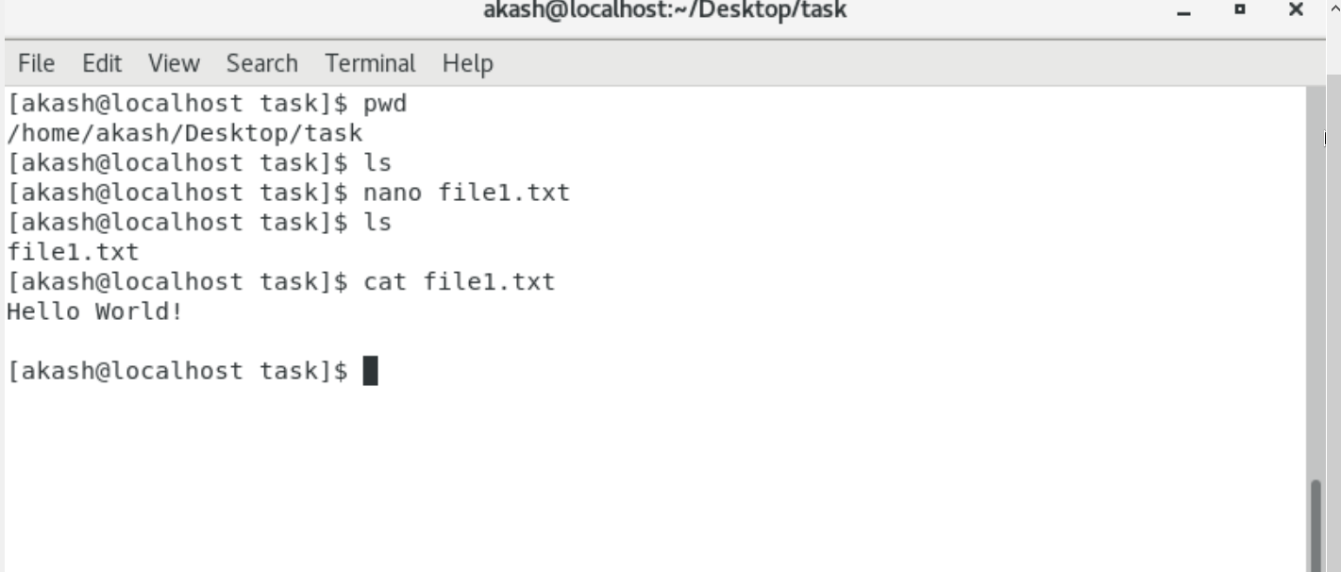

**2. Now we will copy the data from file1 to new file2**

**Answer:**

Copied the contents from file1.txt to file2.txt and displayed the contents of the file2.txt using the cat command.

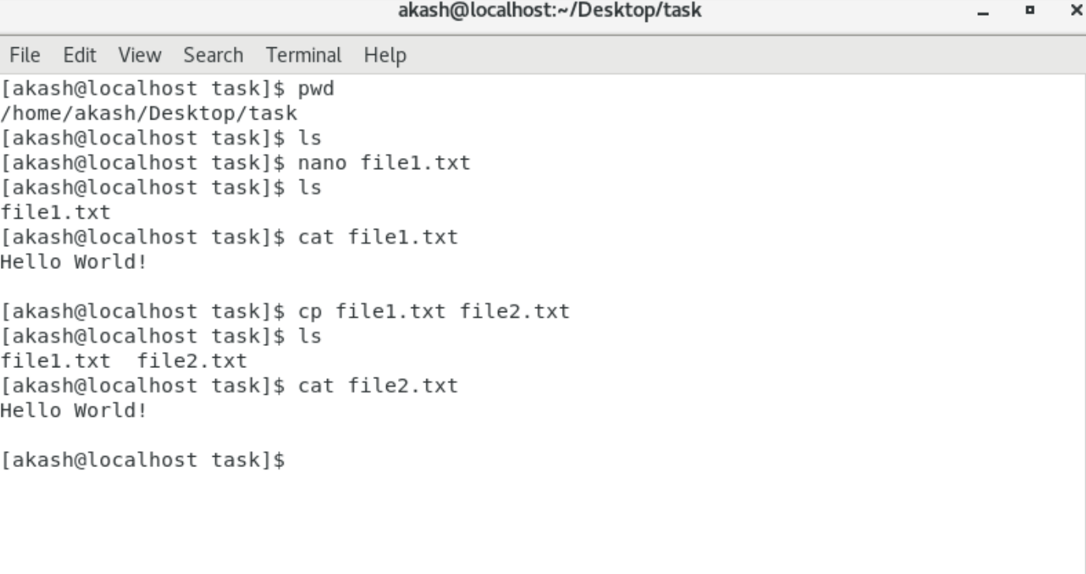

**3. Now we will move the file2.txt to a new folder /home**

**Answer:**

For moving the file2.txt to /home, we need permission, so I logged in as the root user and used the mv command to move the file2.txt and checked the /home using the ls command.

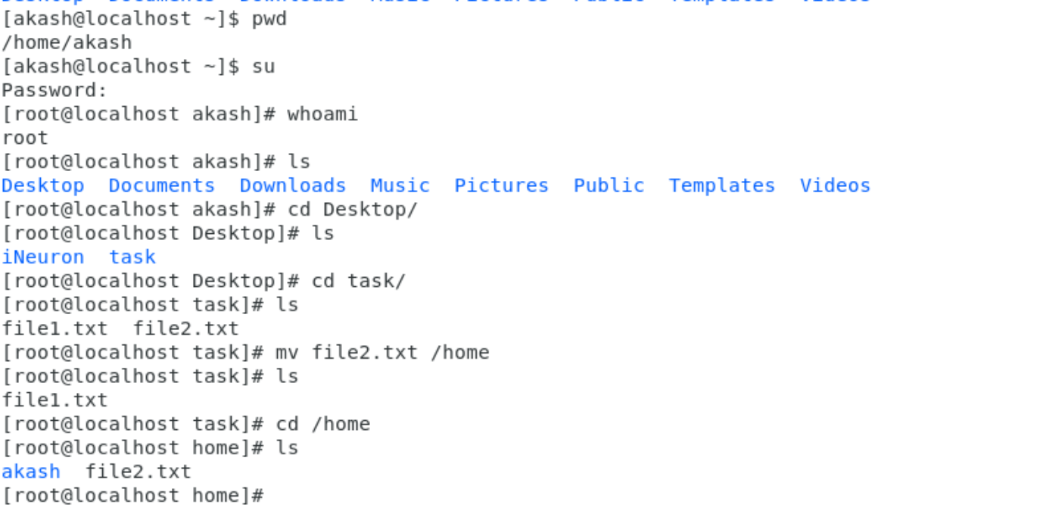

**4. Then we create a new file3.txt and file4.txt in the home directory and add**

**content to it.**

**o Now do echo “Hello I am newline” > file3.txt and provide the output of file3.txt**

**o Now do echo “Hello I am newline” >> file4.txt and provide the output of file4.txt**

**Answer:**

* The echo “....” >file3.txt creates a file3.txt if it does not exits and adds the content to the file. If the file exits then it overrides the contents present in the file with the given content.
* The echo “....”>>file4.txt creates a file4.txt if it does not exits and adds the content to the file. If the file exits then it appends the given content in a new line.

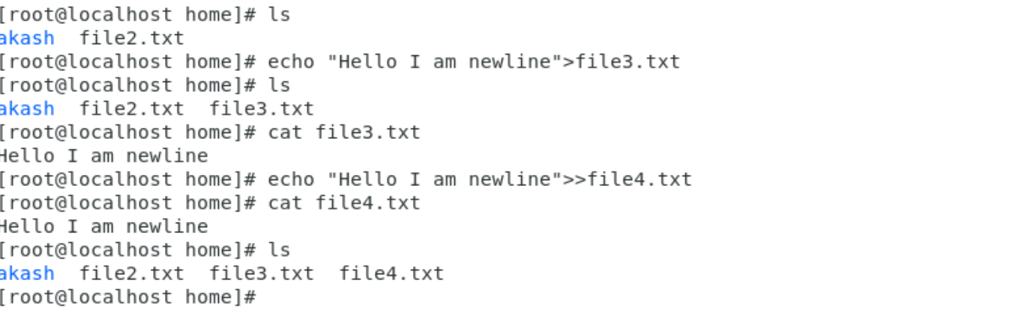

**5. For removing a file or directory you can use the below two commands**

**o To delete a file – rm <any_filename>**

**Answer:**

Deleted 3 files using the rm command.

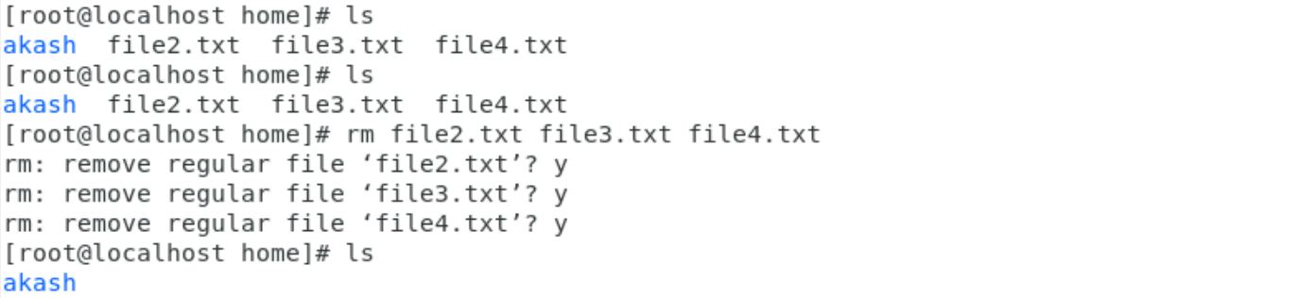

**o To delete a directory -rmdir <any_directoryname>**

**Answer:**

Deleted the task directory using the rmdir command.

